--------- Forwarded message ---------
From: Ferdo Ivanek <ferdo.ivanek@gmail.com>
Date: Tue, Jul 7, 2020 at 11:25 AM
Subject: Re: follow up
To: Maurice <mauricega.bernard@orange.fr>

Dear Maurice,

As you requested, here are the highlights of my exposure to the CNET. But first the background information.

Upon graduation from the Technical University in Vienna, Austria with a thesis on microwave technology, I joined the Radio Institute of the Yugoslav Broadcasting Organization in 1949 and started research in microwave communications. The objective was to install a countrywide radio-relay network for radio program transmission, because the existing PTT network was inadequate for the purpose. For the implementation phase I transferred to Broadcasting Engineering to plan the first application, a link between Belgrade, the capital, and Zagreb, the second largest city. The Yugoslav PTT reluctantly joined the project because, until then, they were planning only open-wire and cable links.

Based on my radio-relay network design we made preliminary inquiries with foreign suppliers. SFR had the most promising system for our application. In 1952 we visited them and other suppliers in France and the UK. On that occasion the SFR representatives took us on a Visit of CNET, where we met Marzin and Sueur. I was very much impressed by what I heard and saw.

Reluctant to leave the initiative for the introduction of a new telecommunications technology to the Broadcasting Organization, the PTT offered me the opportunity to establish a Radio-Relay Latoratory at the PTT Research Institute, which I accepted. The Deputy Director of the PTT responsible for telecommunications was very supportive. He was impressed by what he heard from me about our CNET visit.and my separate earlier visit to the Swiss PTT Research Institute, and asked me to organize a visit for the two of us. Both sides were apparently pleased with the visit and as a result I was able to borrow CNET's 4 GHz propagation test set for tests in Yugoslavia. As a result I gained an influential supporter for radio-relay systems at top management level of the Yugoslav PTT, which greatly helped me to get the necessary broader support among the PTT hierarchy for a first radio-relay link between Belgrade, the capital, and Zagreb, the second largest city, intended for both multichannel telephony and radio program transmission. I prepared the technical specifications for the competition to which companies from France, the UK, Germany and the US were invited. SFR won the competition for the 60/120-channel system operating in the 300 MHz band.

At this point my PTT career got derailed. What led to it was a governmental legislative proposal for the separation of Post and Telecommunications, following the progressive examples of most European countries. Since the postal professionals were in the commanding Yugoslav PTT positions, they naturally advanced arguments against the separation proposal which was of course popular among the engineering professionals. I happened to be among the most vocal ones. But the progressive legislative proposal failed with the help of political maneuvering in the government and I got pushed out. of the PTT.. The same happened to the Deputy Director of the Yugoslav PTT who supported my efforts.

Not surprisingly, I immediately got an attractive job offer from the Institute for Telecommunications in Ljubljana (Slovenian acronyme IEV), that had earlier engaged me as consultant .This gave me the opportunity to pursue my earlier published proposal for planning higher capacity radio-relay links in the 2 GHz band. The time was ripe for this because IEV had already developed a lower capacity system in the 300 GHz band. Since the Director of IEV impressed me as an entrepreneur of the Marzin type, I proposed to him to explore the possibility of technical cooperation between the two organizations. He gave me the go-ahead to approach Marzin with the idea. It found Marzin receptive and he invited us for a visit. When we arrived, Marzin and Sueur presented us with a draft Cooperation Agreement. The two of us found it most satisfactory. Marzin and Sueur showed us around at the CNET, accompanied by Indjoudjian. In the implementation phase of this Cooperation Agreement three engineers from Ljubljana, me included, came to CNET "en stage" for a couple of months, and Marzin and Sueur visited IEV in Ljubljana. They were also favorably impressed. The Yugoslav PTT showed no interest in profiting from this cooperation, but the Yugoslav Army did. The result was the portable microwave link shown in the attached photo, that had been developed and delivered in quantity.

To the best of my recollection, you and I met shortly after you joined CNET, but at that point it was just a brief encounter. My main working contacts at CNET were Libois and Docques. I knew a number of other CNET engineers, like Dayonnet. Other names escape me now, but I recognized a number of those in your book, among them Dezoteux, Dondou and Pinet, but I do not recall the circumstances. I do remember Poitevin who arranged my visit to CNET in 1974, on my way to the European Microwave Conference in Montreux. and Fouad Hanna who organized my IEEE Distinguished Microwave Lecture in 1982.

It was a pleasant surprise to meet you and Françoise at Stanford. in 1962 And passing through Paris on our return to Yugoslavia you invited us for dinner at your apartment in Boulogne Years later, when you visited Stanford as Director of CNET, I organized for you an IEEE presentation on French telecommunications development in which you highlighted the Minitel. Yes, I vividly remember our visit to your estate in Anjou! 1985? I have photos from that occasion, but I would be hard pressed to find them. Our more recent brief encounters are of course in fresher memory, especially the last one with Françoise in 2009.

Greetings,

Ferdo
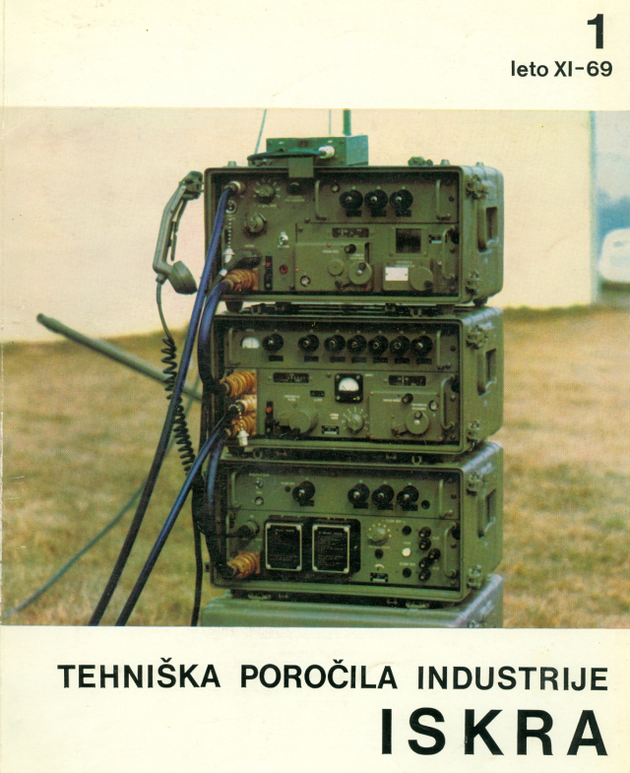

On Mon, Jul 6, 2020 at 6:48 AM Maurice <mauricega.bernard@orange.fr> wrote:
Bonjour ferdo,
I hope California remains safe.
On my hand I tried to find witnesses vho remember your professionnal
visits in France and Europe? So many people passed away: THUE, VOGE, and
others. Dikran Indjoudjian , still alive (But 100 years last february)
could not tell me very much about you in CNET. I remain alone with
remembering your visits in Anjou with your wife.
Ihope tohear more from you Ferdo

